**MULTIFAMILY GROUPS IN MENTAL HEALTH (FA.M.HE.)  
  
2nd TRANSNATIONAL MEETING - LISBON - PORTUGAL**

**FEBRUARY 24, 2023**

**RELEVANCE OF MULTIFAMILY GROUPS**

**IN MENTAL HEALTH**

**A MEETING BETWEEN THE WORLD LANGUAGE AND THE PRIVATE LANGUAGE IN THE MULTIFAMILY GROUP**

**INTRODUCTION**

Multifamily Groups (MFG) as a model of care in psychiatry are an essential therapeutic device.

It involves families in the treatment, ensuring ***a better compliance with the therapeutic project***.

It takes into account the fact that the family is a ***“partner” in caring for the patients*,** in its unique knowledge of the family history, of its emotional and financial interdependencies, among others.

**THE EVERYDAY LANGUAGE / THE LANGUAGE OF PATIENTS IN MULTIFAMILY GROUPS[1]**

* ***The Private language*** *“is the “internal” representation of our individual references as a speaking being, it is our subjective choice.”*
* ***The World language*** *“refers to a language, a common civilizational sharing.”*

**This care model is described in 5 stages by Dr. Passelecq, Nurse Truyers and Psychologist Laplace:**

1. **Childhood: Attachment period**
2. **Adolescence: Reattachment period**
3. **Patient in crisis: Detachment period**
4. **Outpatient (OP) Hospital/Multifamily Group: Working on reattachment period**
5. **Post-discharge: Mobilization period**
6. **Childhood: Attachment period**

It situates the ***Private Language*** based on the choice that each subject will make of his/her history, even before subjecting it, schematically representing our psychic references.

The child’s ***World*** ***Language*** is essentially the first “language bath” (Jacques Lacan), represented by parental/caregiver figures.

**Childhood: Attachment period**

A language emerges that allows the child to say « I »

1. **Adolescence: Reattachment period**

Regarding the language of young people, it is the language spoken by adolescents through the compromise they make between their private language and the World language.

The young person’s language is the knowledge, of oneself linked to the knowledge of the Other, and vice versa.

The flow between these two types of knowledge is continuous, and the articulation of one and the other:

**It allows for the individual to think about oneself without feeling disconnected from the world and to think about the world without feeling disconnected from oneself.**

**Adolescence: Reattachment period**

An individual language emerges

from the young person

allowing them to say « I »

1. **Patient in crisis: Detachment**

The patient in crisis breaks with his/her own language (private language) and with the knowledge of the world (world language), takes refuge behind a symptom that becomes incomprehensible to his/her family members.

*Regarding the world language,* language is detached from the subjectivity and responsibility for what causes the symptom. The patient overinvests the knowledge that surrounds him/her, and interprets oneself based on a language other than his/her own. The patient sees oneself as being talked about rather than verbalizing one´s thoughts and feelings.

*Regarding the private language,* isolated from the knowledge of the world, the patient makes it impossible to interpret the symptom, living as if he/she were outside of reality and he/she does not see how they can be inscribed in a world that does not understand him/her. By disconnecting from the other's language, the patient’s private language becomes untranslatable by oneself and by the world.

**Patient in crisis:**

**Detachment period**

The « I»

Starts expressing oneself by the sympto

m

severance

severance

1. **Outpatient Hospital/Multifamily Group: Working on reattachment period**

* MFG is a privileged space, where it becomes possible to translate the world language and the patient’s private language.
* Moment of learning, passage, and reunion.
* Place of connection between the knowledge of the world (different families and team) and the unique language of the patient, differentiating them in order to re-articulate them.
* The goal is to (re)mobilize a work of separation/individualization.

**Outpatient Hospital/**

**Multifamily Group: Reattachment period**



Rebuilding of the

« I » by a way other than through the symptom

**NURSING AND MFG:**

* Liaison agent, a bridge between private language and the world language between the Institution and the Family;
* Provide a therapeutic structure where the user realizes oneself in the world language, and thus rebuilds his/her “SELF” in a way other than through the symptom;
* Mobilize the world language to the private language (studies, work,...);
* Mobilize the work of separation, differentiation and individualization, necessary for the therapeutic process.

**Tool nr. 1: Genogram**

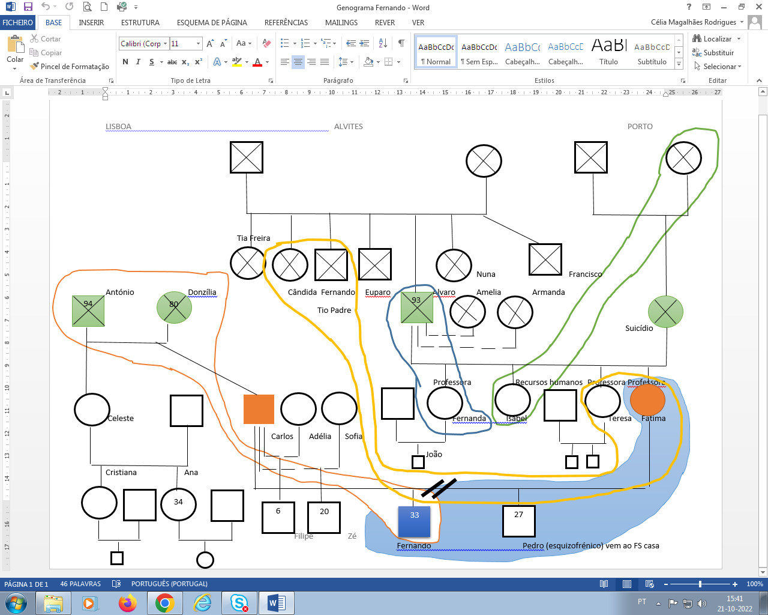

**Tool nr. 2: Life Line**

**Sep 21**

Birth of sister (Mother was 19 years old)

Mother had ectopic pregnancy and underwent emergency surgery, had an ovary removed

**May 3rd**

M. birth

**12 years old**

Parents’ divorce

**16/17 years old**

Abusive/violent relationship with boyfriend

**18 years old**

Parents’ divorce

**Dec 24:** Brain dead mother

**Dec 25:** Mother's death

1981

1987

1999

2004

2005

2016

2017

2018

2019

2020

2021

**Aug 3rd**

Birth of daughter Clara

32 wks: stops feeling the baby

32 wks 🡪 35 wks: goes home

35sem: emergency c-section

**April 06**

Death of Grandfather on mother’s side

**Nov 25**

Myocarditis. Patient undergoes catheterization

**Sep 29**

Father's death.

Oncological disease, colorectal cancer

**Jan 16**

Birth of daughter L. (40cm)

**May 27**

Enters the Outpatient Hospital

1st leave

Father puts money from the Lawyers’ office in the husband’s name …”It ruined my life”

1. **Post-discharge: Mobilization period**

Mobilization is the moment when the hospital stay as an attachment place between the World Language and the Private Language ceases to be necessary because he/she has found a strong enough joining point to be able to speak his/her language in the world.

A period for signifier consolidation (culture, work, family,…) that supports and values the patients’ lives.

**Post-discharge: Mobilization period**

The « I »

can rebuild oneself

**CONCLUSION**

These are the two lines of work that we defend, not pathologizing the signifier but allowing the subject to establish new links with the world around him in order to anchor and define himself.

The functioning achieved through the liaison agents – the agents seek to provide a framework where the patient feels fulfilled in the language of the World, without having to report his discomfort and its interpretation to people other than those involved in his private language (psychotherapist individual and family).

This does not mean that suffering is not spoken elsewhere, but it will not then find an address towards caregivers who would lend themselves to a place of interpreter of the unconscious.

It is therefore a question of affirming a response which distinguishes the treatment of the symptom by its explanation, from that where interpretations are not required or even admitted, in order to allow the young person to situate his private language as at the same time differentiated from the language of the World, but also because of a language which serves to represent oneself with dignity.

**Multifamily Group and Healthcare Professionals:**

**Reattachment TOOL**



**Psychologists**

The language work is developed as a private, family and individual language

**MFG**

**Occupational therapist** (group activities = representing a micro society), **Dietician, Social worker,…**

**Links: Nurses**

the “bridge” that will connect all care provided

Links: Physicians responsible/Service Coordinator

**REFERENCES**

* FIERENS CH. La famille à quoi ça sert? Comment ça serre?. In: Bulletin Freudien, n° 58/59, Décembre 2013, p. 187-198
* MEYNCKENS M. et al. Eduquer et soigner en équipe: Manuel de pratique institutionnelle. 1er édition. Bruxelles : De Boeck, 2011. 416 p. (Carrefour des psychothérapies).
* PASSELECQ A. et al. Formation et enseignement. Bruxelles: De boeck, 2013. p. 209 (Cahiers de psychologie clinique ; 41)
* SCHAERER R. le malade et sa famille face à la maladie grave, 5, 6 & 7 juin 2003, Nice .9ème congrès de la société française d’accompagnement et de soins palliatifs, 2003. 480 p.
* SAMPAIO, et al.Modelo de intervenção psicoterapêutica em enfermagem: Princípios orientadores para a implementação na prática clínica. Revista Portuguesa de Enfermagem de Saúde Mental (19),2018, 77-84. Disponível em http://dx.doi.org/10.19131/rpesm.0205
* ZANOVY L., M’BAILARA K. et MINOIS I. Penser un groupe multifamilial en psychiatrie adulte. In : Journal des Psychologues, n° 313, Décembre/Janvier 2014, p. 37-41

1. PASSELECQ A. et al. Formation et enseignement. Bruxelles : De boeck, 2013. p. 209 (Cahiers de psychologie clinique ; 41)